

Jared Hermans

EEL 5661 Homework 2

Dr. Zvi Roth

**Problem 1:**

Refer to Problems 2 and 3 of HW1, in which you derived the forward kinematics of two robots.

* Perform the inverse kinematics of the two manipulator
* Use RTB to create the two robots and to perform the inverse kinematics on some chosen poses.

**Inverse Kinematics #2:**

The Final 4x4 forward kinematic equation I obtained in question 2 was:

$$T=A_{1}A_{2}A_{3}A_{4}A_{5}=\left[\begin{matrix}-S_{5} & 0 & -C_{5} & d_{4} \\ {-S}_{4}C_{5} & 0 & S_{4}S_{5}-C_{4} & d_{2}+d_{3}-C_{4}d_{5}-S_{4}a_{4} \\ C_{4}C_{5} & 0 & -C_{4}S_{5}-S_{4} & -S_{4}d_{5}+C_{4}a_{4}+d_{1} \\ 0 & 0 & 0 & 1\end{matrix}\right]=\left[\begin{matrix}n_{x} & o_{x} & a_{x} & p_{x} \\ n_{y} & o_{y} & a_{y} & p_{y} \\ n_{z} & o_{z} & a_{z} & p_{z} \\ 0 & 0 & 0 & 1\end{matrix}\right]$$

$$A_{1}={}_{1}^{0}{T(q_{1})}=\left[\begin{matrix}1 & 0 & 0 & 0 \\ 0 & 0 & 1 & 0 \\ 0 & -1 & 0 & d_{1} \\ 0 & 0 & 0 & 1\end{matrix}\right]$$

$$A_{2}={}_{2}^{1}{T(q_{2})}=\left[\begin{matrix}0 & 1 & 0 & 0 \\ -1 & 0 & 0 & 0 \\ 0 & 0 & 1 & d_{2} \\ 0 & 0 & 0 & 1\end{matrix}\right]$$

$$A_{3}={}_{3}^{2}{T(q_{3})}=\left[\begin{matrix}1 & 0 & 0 & 0 \\ 0 & 0 & 1 & 0 \\ 0 & -1 & 0 & d_{3} \\ 0 & 0 & 0 & 1\end{matrix}\right]$$

$$A_{4}={}_{4}^{3}{T\left(q_{4}\right)=}\left[\begin{matrix}C_{4} & 0 & -S_{4} & a_{4}C_{4} \\ S_{4} & 0 & C_{4} & a_{4}S_{4} \\ 0 & -1 & 0 & d_{4} \\ 0 & 0 & 0 & 1\end{matrix}\right]$$

$$A_{5}={}_{5}^{4}{T(q_{5})}=\left[\begin{matrix}C_{5} & -S_{5} & 0 & 0 \\ S_{5} & C_{5} & 0 & 0 \\ 0 & 0 & 1 & d_{5} \\ 0 & 0 & 0 & 1\end{matrix}\right]$$

$$T={}_{1}^{0}{T(q_{1})∙}{}_{2}^{1}{T(q_{2})}∙{}_{3}^{2}{T(q_{3})∙}{}_{4}^{3}{T(q_{4})∙}{}_{5}^{4}{T(q_{5})}$$

To find the inverse kinematics for the first joint $d_{1}$ as a function of the known elements of ${}_{end-effector}^{base}T$, the link transformation inverses are pre-multiplied as follows.

$${[{}_{1}^{0}{T(q_{1})]}}^{-1}∙T={[{}_{1}^{0}{T(q_{1})]}}^{-1}∙{}_{1}^{0}{T(q_{1})∙}{}_{2}^{1}{T(q_{2})}∙{}_{3}^{2}{T(q_{3})∙}{}_{4}^{3}{T(q_{4})∙}{}_{5}^{4}{T(q_{5})}$$

Where ${[{}_{1}^{0}{T(q_{1})]}}^{-1}∙{}_{1}^{0}{T(q_{1})}$ is equal to the identity matrix. The above equation then simplifies to:

${[{}_{1}^{0}{T(q_{1})]}}^{-1}∙T={}_{2}^{1}{T(q_{2})}∙{}_{3}^{2}{T(q_{3})∙}{}_{4}^{3}{T(q_{4})∙}{}_{5}^{4}{T(q_{5})}$ [ 1]

The rest of the equations are obtained in a similar manner:

${[{}_{1}^{0}{T(q_{1})∙{}_{2}^{1}{T(q_{1})}]}}^{-1}∙T={}_{3}^{2}{T(q_{3})∙}{}_{4}^{3}{T(q_{4})∙}{}_{5}^{4}{T(q_{5})}$ [ 2]

${[{}_{1}^{0}{T(q_{1})∙{}_{2}^{1}{T(q_{1})}∙{}_{3}^{2}{T(q_{1})}]}}^{-1}∙T={}_{4}^{3}{T(q_{4})∙}{}_{5}^{4}{T(q_{5})}$ [ 3]

${[{}_{1}^{0}{T(q_{1})∙{}_{2}^{1}{T(q_{1})}∙{}_{3}^{2}{T(q_{1})∙}{}_{4}^{3}{T(q_{1})}]}}^{-1}∙T={}_{5}^{4}{T(q_{5})}$ [ 4]

Looking at equation 1:

$${\left[\begin{matrix}1 & 0 & 0 & 0 \\ 0 & 0 & 1 & 0 \\ 0 & -1 & 0 & d_{1} \\ 0 & 0 & 0 & 1\end{matrix}\right]}^{-1}\left[\begin{matrix}n_{x} & o_{x} & a_{x} & p_{x} \\ n_{y} & o_{y} & a_{y} & p_{y} \\ n_{z} & o_{z} & a_{z} & p_{z} \\ 0 & 0 & 0 & 1\end{matrix}\right]=\left[\begin{matrix}0 & 1 & 0 & 0 \\ -1 & 0 & 0 & 0 \\ 0 & 0 & 1 & d_{2} \\ 0 & 0 & 0 & 1\end{matrix}\right]\left[\begin{matrix}1 & 0 & 0 & 0 \\ 0 & 0 & 1 & 0 \\ 0 & -1 & 0 & d_{3} \\ 0 & 0 & 0 & 1\end{matrix}\right]\left[\begin{matrix}C_{4} & 0 & -S_{4} & a_{4}C_{4} \\ S_{4} & 0 & C_{4} & a_{4}S_{4} \\ 0 & -1 & 0 & d_{4} \\ 0 & 0 & 0 & 1\end{matrix}\right]\left[\begin{matrix}C_{5} & -S_{5} & 0 & 0 \\ S_{5} & C_{5} & 0 & 0 \\ 0 & 0 & 1 & d_{5} \\ 0 & 0 & 0 & 1\end{matrix}\right]$$

$$\left[\begin{matrix}n_{x} & o_{x} & a_{x} & p_{x} \\ {-n}_{z} & {-o}_{z} & a_{z} & {d_{1}-p}_{z} \\ n_{y} & o_{y} & a_{y} & p_{y} \\ 0 & 0 & 0 & 1\end{matrix}\right]=\left[\begin{matrix}-S_{4}S_{5} & {-S}_{4}C_{5} & 0 & d_{4} \\ {-C}_{4}C_{5} & C_{4}S_{5} & S_{4} & S_{4}d_{5}-C_{4} \\ {-S}_{4}C_{5} & S_{4}S_{5} & {-C}_{4} & d_{3}+d_{2}-C_{4}d_{5}-S_{4} \\ 0 & 0 & 0 & 1\end{matrix}\right]$$

The next step is to set the matrix elements equal to each other to look for a suitable equation for the first angle such as:

$$a_{y}={-C}_{4}$$

$$C_{4}={-a}_{y}$$

Since, $C_{i}^{2}+S_{i}^{2}=1 \left(i=1,2,3,…\right), S_{4}$ is obtained as:

$$S_{4}=±\sqrt{1-{({-a}_{y})}^{2}}$$

The two possible solutions for $θ_{4}$ can then be written as:

$$θ_{4}=Atan2(±\sqrt{1-{\left({-a}_{y}\right)}^{2}},{-a}_{y})$$

Another suitable equation is:

$$o_{y}=S_{4}S_{5}$$

$$S_{5}=\frac{o_{y}}{S_{4}}$$

Since, $C_{i}^{2}+S_{i}^{2}=1 \left(i=1,2,3,…\right), C_{5}$ is obtained as:

$$C_{5}=±\sqrt{1-{(\frac{o_{y}}{S_{4}})}^{2}}$$

The two possible solutions for $θ_{5}$ can then be written as:

$$θ_{5}=Atan2(\frac{o_{y}}{S_{4}},±\sqrt{1-{\left(\frac{o_{y}}{S_{4}}\right)}^{2}})$$

The equation has $θ_{4}$ however we found the equation for $θ_{4}$ previously.

Prismatic joint $d_{1}$ is found easily, remember $d_{5}$ is a fixed distance:

$$d_{1}-p_{z}=S_{4}d_{5}-C_{4}$$

$$d_{1}=p_{z}+S_{4}d_{5}-C_{4}$$

Equation 1 does not have a suitable equation to find prismatic joints $d_{2}$ and $d_{3}$ so we will use equation 3:

$${\left[\begin{matrix}1 & 0 & 0 & 0 \\ 0 & 0 & 1 & 0 \\ 0 & -1 & 0 & d_{1} \\ 0 & 0 & 0 & 1\end{matrix}\right]}^{-1}{\left[\begin{matrix}0 & 1 & 0 & 0 \\ -1 & 0 & 0 & 0 \\ 0 & 0 & 1 & d_{2} \\ 0 & 0 & 0 & 1\end{matrix}\right]}^{-1}{\left[\begin{matrix}1 & 0 & 0 & 0 \\ 0 & 0 & 1 & 0 \\ 0 & -1 & 0 & d_{3} \\ 0 & 0 & 0 & 1\end{matrix}\right]}^{-1}\left[\begin{matrix}n_{x} & o_{x} & a_{x} & p_{x} \\ n_{y} & o_{y} & a_{y} & p_{y} \\ n_{z} & o_{z} & a_{z} & p_{z} \\ 0 & 0 & 0 & 1\end{matrix}\right]=\left[\begin{matrix}C_{4} & 0 & -S_{4} & a_{4}C_{4} \\ S_{4} & 0 & C_{4} & a_{4}S_{4} \\ 0 & -1 & 0 & d_{4} \\ 0 & 0 & 0 & 1\end{matrix}\right]\left[\begin{matrix}C_{5} & -S_{5} & 0 & 0 \\ S_{5} & C_{5} & 0 & 0 \\ 0 & 0 & 1 & d_{5} \\ 0 & 0 & 0 & 1\end{matrix}\right]$$

$$\left[\begin{matrix}n_{z} & o_{z} & a_{f} & p_{z}-d_{3} \\ {-n}_{y} & -o_{y} & -a_{y} & -p_{y}+d_{1}+d_{2} \\ n_{x} & o_{x} & a_{x} & p_{x} \\ 0 & 0 & 0 & 1\end{matrix}\right]=\left[\begin{matrix}{C_{4}C}_{5} & -C_{4}S_{5} & -S_{4} & C_{4}-S_{4}d_{5} \\ C_{5}S_{4} & -S_{4}S_{5} & C_{4} & C_{4}d_{5}+S_{4} \\ -S_{5} & -C_{5} & 0 & d_{4} \\ 0 & 0 & 0 & 1\end{matrix}\right]$$

A suitable equation is:

$$-p_{y}+d_{1}+d_{2}=C_{4}d_{5}+S_{4}$$

Prismatic joint $d_{2}$:

$$d_{2}=C_{4}d_{5}+S_{4}+p_{y}-d_{1}$$

Prismatic joint $d_{3}$:

$$p_{z}-d_{3}=C_{4}-S_{4}d_{5}$$

$$d_{3}=p_{z}-C_{4}+S_{4}d_{5}$$

**MATLAB #2:**

In the first section of the code we import the Hitachi Mr. Aros robot created in homework 1 so we can work with it. In the next section, the robot is plotted using different joint angles. In the last section a transformation matrix is created for a certain pose of the robot and the RTB function ikine is used to find the joint angles from that transformation matrix. Then it is plotted.

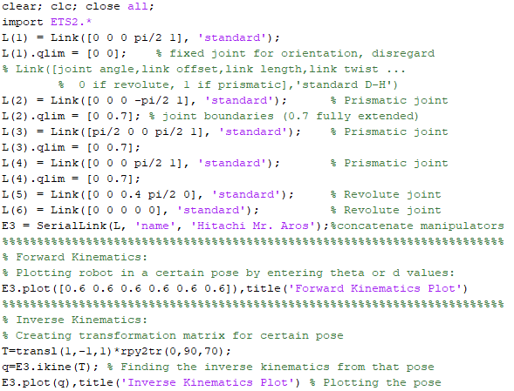

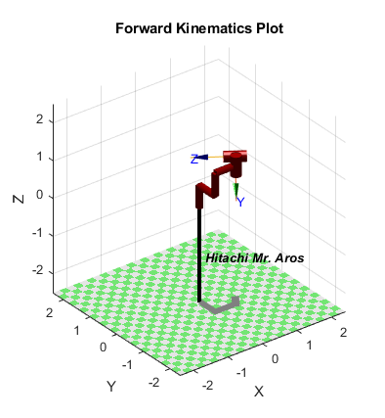

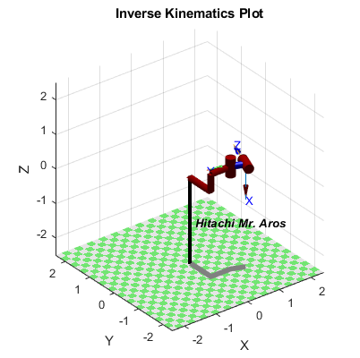



Here we can see the 6 joint angle values found from the ikine function. Remember from HW 1 that the robot was created with joint 1 as a fixed joint in order to orientate the robot in the correct position which is why its value is 0.

**Inverse Kinematics #3:**

The Final 4x4 forward kinematic equation I obtained in question 3 was:

$$T=A_{1}A_{2}A_{3}A_{4}=\left[\begin{matrix}C_{4}\left(C_{1}C_{2}-S_{2}S_{1}\right)+S_{4}(S_{1}C_{2}+S_{2}C_{1}) & C_{4}\left(S_{1}C_{2}+S_{2}C_{1}\right)-S_{4}(C_{1}C_{2}-S_{2}S_{1}) & 0 & C_{1}C_{2}a_{2}+C_{1}a_{1}-S_{2}S_{1}a_{2} \\ C_{4}\left(S_{1}C_{2}+S_{2}C_{1}\right)+S_{4}(S_{2}S_{1}-C_{1}C_{2}) & C_{4}\left(S_{2}S_{1}-C_{1}C_{2}\right)-S_{4}(S_{1}C_{2}+S_{2}C_{1)} & 0 & S_{1}C_{2}a_{2}+S_{1}a_{1}+S_{2}C_{1}a_{2} \\ 0 & 0 & -1 & -d_{3}-1 \\ 0 & 0 & 0 & 1\end{matrix}\right]=\left[\begin{matrix}n_{x} & o_{x} & a_{x} & p_{x} \\ n_{y} & o_{y} & a_{y} & p_{y} \\ n_{z} & o_{z} & a_{z} & p_{z} \\ 0 & 0 & 0 & 1\end{matrix}\right]$$

$a_{1}$ and $a_{2}=1$:

$$A_{1}={}_{1}^{0}{T(q_{1})}=\left[\begin{matrix}C_{1} & -S_{1} & 0 & C_{1} \\ S_{1} & C_{1} & 0 & S_{1} \\ 0 & 0 & 1 & 0 \\ 0 & 0 & 0 & 1\end{matrix}\right]$$

$$A_{2}={}_{2}^{1}{T(q_{2})}=\left[\begin{matrix}C_{2} & S_{2} & 0 & C_{2} \\ S_{2} & -C_{2} & 0 & S_{2} \\ 0 & 0 & -1 & 0 \\ 0 & 0 & 0 & 1\end{matrix}\right]$$

$$A_{3}={}_{3}^{2}{T(q_{3})}=\left[\begin{matrix}1 & 0 & 0 & 0 \\ 0 & 1 & 0 & 0 \\ 0 & 0 & 1 & d_{3} \\ 0 & 0 & 0 & 1\end{matrix}\right]$$

$$A_{4}={}_{4}^{3}{T\left(q_{4}\right)=}\left[\begin{matrix}C_{4} & -S_{4} & 0 & 0 \\ S_{4} & C_{4} & 0 & 0 \\ 0 & 0 & 1 & d_{4} \\ 0 & 0 & 0 & 1\end{matrix}\right]$$

$$T={}_{1}^{0}{T(q_{1})∙}{}_{2}^{1}{T(q_{2})}∙{}_{3}^{2}{T(q_{3})∙}{}_{4}^{3}{T(q_{4})}$$

Looking at equation 1 without the term ${}_{5}^{4}{T(q_{5})}$; remember $S_{i}={sin⁡(θ}_{i})$ and $C_{i}={cos⁡(θ}_{i})$:

$${\left[\begin{matrix}C_{1} & -S_{1} & 0 & C_{1} \\ S_{1} & C_{1} & 0 & S_{1} \\ 0 & 0 & 1 & 0 \\ 0 & 0 & 0 & 1\end{matrix}\right]}^{-1}\left[\begin{matrix}n_{x} & o_{x} & a_{x} & p_{x} \\ n_{y} & o_{y} & a_{y} & p_{y} \\ n_{z} & o_{z} & a_{z} & p_{z} \\ 0 & 0 & 0 & 1\end{matrix}\right]=\left[\begin{matrix}C_{2} & S_{2} & 0 & C_{2} \\ S_{2} & -C_{2} & 0 & S_{2} \\ 0 & 0 & -1 & 0 \\ 0 & 0 & 0 & 1\end{matrix}\right]\left[\begin{matrix}1 & 0 & 0 & 0 \\ 0 & 1 & 0 & 0 \\ 0 & 0 & 1 & d_{3} \\ 0 & 0 & 0 & 1\end{matrix}\right]\left[\begin{matrix}C_{4} & -S_{4} & 0 & 0 \\ S_{4} & C_{4} & 0 & 0 \\ 0 & 0 & 1 & d_{4} \\ 0 & 0 & 0 & 1\end{matrix}\right]$$

$$\left[\begin{matrix}\frac{-n_{y}S_{1}-C_{1}n_{x}}{-S_{1}^{2}-C_{1}^{2}} & \frac{-C_{1}o_{x}-S_{1}o_{y}}{-S_{1}^{2}-C_{1}^{2}} & \frac{-C_{1}a_{x}-S_{1}a_{y}}{-S_{1}^{2}-C_{1}^{2}} & \frac{-C_{1}p_{x}-S_{1}p_{y}+S_{1}^{2}+C_{1}^{2}}{-S_{1}^{2}-C_{1}^{2}} \\ \frac{n_{x}S_{1}-C_{1}n_{y}}{-S_{1}^{2}-C_{1}^{2}} & \frac{S_{1}o_{x}-C_{1}o_{y}}{-S_{1}^{2}-C_{1}^{2}} & \frac{a_{x}S_{1}-C_{1}a_{y}}{-S_{1}^{2}-C_{1}^{2}} & \frac{p_{x}S_{1}-C_{1}p_{y}}{-S_{1}^{2}-C_{1}^{2}} \\ n_{z} & o_{z} & a_{z} & p_{z} \\ 0 & 0 & 0 & 1\end{matrix}\right]=\left[\begin{matrix}C_{2}C_{4}+S_{2}S_{4} & S_{2}C_{4}-C_{2}S_{4} & 0 & C_{2} \\ S_{2}C_{4}-C_{2}S_{4} & {-C}_{2}C_{4}-S_{2}S_{4} & 0 & S_{2} \\ 0 & 0 & -1 & {-d}_{3}-d_{4} \\ 0 & 0 & 0 & 1\end{matrix}\right]$$

$$\left[\begin{matrix}n_{y}S_{1}+C_{1}n_{x} & C_{1}o_{x}+S_{1}o_{y} & C_{1}a_{x}+S_{1}a_{y} & C_{1}p_{x}+S_{1}p_{y}-S_{1}^{2}-C_{1}^{2} \\ {-n}_{x}S_{1}+C_{1}n_{y} & {-S}_{1}o_{x}+C_{1}o_{y} & {-a}_{x}S_{1}+C_{1}a_{y} & {-p}_{x}S_{1}+C_{1}p_{y} \\ n_{z} & o_{z} & a_{z} & p_{z} \\ 0 & 0 & 0 & 1\end{matrix}\right]=\left[\begin{matrix}C_{2}C_{4}+S_{2}S_{4} & S_{2}C_{4}-C_{2}S_{4} & 0 & C_{2} \\ S_{2}C_{4}-C_{2}S_{4} & {-C}_{2}C_{4}-S_{2}S_{4} & 0 & S_{2} \\ 0 & 0 & -1 & {-d}_{3}-d_{4} \\ 0 & 0 & 0 & 1\end{matrix}\right]$$

The next step is to set the matrix elements equal to each other to look for a suitable equation for the first angle such as:

$$-a_{x}S_{1}+C_{1}a_{y}=0$$

$$a_{x}S_{1}=C_{1}a_{y}$$

$$\tan\left(θ_{1}\right)=\frac{a_{y}}{a_{x}}$$

The two possible solutions for $θ_{1}$ can then be written as:

$$θ_{1}=Atan2(±a_{y},±a_{x})$$

Another suitable equation is:

$$C_{1}p_{x}+S_{1}p_{y}-S_{1}^{2}-C_{1}^{2}=C_{2}$$

$$C_{2}=C_{1}p_{x}+S_{1}p_{y}-1$$

Since, $C_{i}^{2}+S_{i}^{2}=1 \left(i=1,2,3,…\right), S_{2}$ is obtained as:

$$S_{2}=±\sqrt{1-{(C_{1}p_{x}+S_{1}p_{y}-1)}^{2}}$$

The two possible solutions for $θ_{2}$ can then be written as:

$$θ_{2}=Atan2(±\sqrt{1-{\left(C_{1}p_{x}+S_{1}p_{y}-1\right)}^{2}},C_{1}p_{x}+S_{1}p_{y}-1)$$

Prismatic joint $d_{3}$ can be found easily; remember $d_{4}$ is a fixed distance:

$$p_{z}={-d}_{3}-d_{4}$$

$$d_{3}=-p_{z}-d_{4}$$

Equation 1 does not have a suitable equation to find $θ_{4}$ so we will use equation 2 without the ${}_{5}^{4}{T(q_{5})}$ term:

$${\left[\begin{matrix}C_{1} & -S_{1} & 0 & C_{1} \\ S_{1} & C_{1} & 0 & S_{1} \\ 0 & 0 & 1 & 0 \\ 0 & 0 & 0 & 1\end{matrix}\right]}^{-1}{\left[\begin{matrix}C_{2} & S_{2} & 0 & C_{2} \\ S_{2} & -C_{2} & 0 & S_{2} \\ 0 & 0 & -1 & 0 \\ 0 & 0 & 0 & 1\end{matrix}\right]}^{-1}\left[\begin{matrix}n_{x} & o_{x} & a_{x} & p_{x} \\ n_{y} & o_{y} & a_{y} & p_{y} \\ n_{z} & o_{z} & a_{z} & p_{z} \\ 0 & 0 & 0 & 1\end{matrix}\right]=\left[\begin{matrix}1 & 0 & 0 & 0 \\ 0 & 1 & 0 & 0 \\ 0 & 0 & 1 & d_{3} \\ 0 & 0 & 0 & 1\end{matrix}\right]\left[\begin{matrix}C_{4} & -S_{4} & 0 & 0 \\ S_{4} & C_{4} & 0 & 0 \\ 0 & 0 & 1 & d_{4} \\ 0 & 0 & 0 & 1\end{matrix}\right]$$

$$\left[\begin{matrix}\frac{n_{y}\left(C_{2}S_{1}-C_{1}S_{2}\right)+n_{x}({-C}_{1}C_{2}-S_{1}S_{2})}{(S_{2}^{2}+C_{2}^{2})(-S_{1}^{2}-C_{1}^{2})} & … & … & … \\ \frac{n_{y}\left(C_{1}C_{2}+S_{1}S_{2}\right)+n_{x}(C_{2}S_{1}-C_{1}S_{2})}{(S_{2}^{2}+C_{2}^{2})(-S_{1}^{2}-C_{1}^{2})} & … & … & … \\ … & … & … & … \\ 0 & 0 & 0 & 1\end{matrix}\right]=\left[\begin{matrix}C_{4} & -S_{4} & 0 & 0 \\ S_{4} & C_{4} & 0 & 0 \\ 0 & 0 & 1 & d_{3}+d_{4} \\ 0 & 0 & 0 & 1\end{matrix}\right]$$

$$\left[\begin{matrix}n_{y}\left({-C}_{2}S_{1}+C_{1}S_{2}\right)+n_{x}(C_{1}C_{2}+S_{1}S_{2}) & … & … & … \\ n_{y}\left({-C}_{1}C_{2}-S_{1}S_{2}\right)+n_{x}({-C}_{2}S_{1}+C_{1}S_{2}) & … & … & … \\ … & … & … & … \\ 0 & 0 & 0 & 1\end{matrix}\right]=\left[\begin{matrix}C_{4} & -S_{4} & 0 & 0 \\ S_{4} & C_{4} & 0 & 0 \\ 0 & 0 & 1 & d_{3}+d_{4} \\ 0 & 0 & 0 & 1\end{matrix}\right]$$

A suitable equation is:

$$C_{4}=n_{y}\left({-C}_{2}S_{1}+C_{1}S_{2}\right)+n_{x}(C_{1}C_{2}+S_{1}S_{2})$$

Since, $C_{i}^{2}+S_{i}^{2}=1 \left(i=1,2,3,…\right), S_{4}$ is obtained as:

$$S_{4}=±\sqrt{1-{(n_{y}\left({-C}_{2}S_{1}+C_{1}S_{2}\right)+n_{x}(C_{1}C_{2}+S_{1}S_{2}))}^{2}}$$

The two possible solutions for $θ_{4}$ can then be written as:

$$θ_{4}=Atan2(±\sqrt{1-{\left(n_{y}\left({-C}_{2}S_{1}+C_{1}S_{2}\right)+n_{x}\left(C_{1}C_{2}+S_{1}S_{2}\right)\right)}^{2}},n_{y}\left({-C}_{2}S_{1}+C_{1}S_{2}\right)+n_{x}\left(C_{1}C_{2}+S_{1}S_{2}\right))$$

**MATLAB #3:**

In the first section of the code I imported the Pentel GL-50 robot created in homework 1. In the next section, the robot is plotted using different joint angles. In the last section a transformation matrix is created for a certain pose of the robot and the RTB function ikine is used to find the joint angles from that transformation matrix. Then it is plotted.

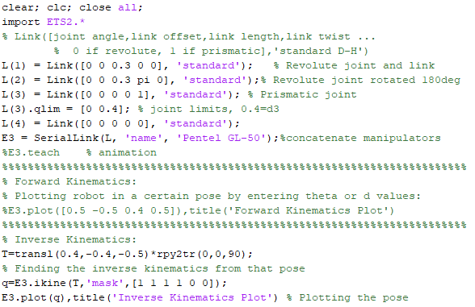

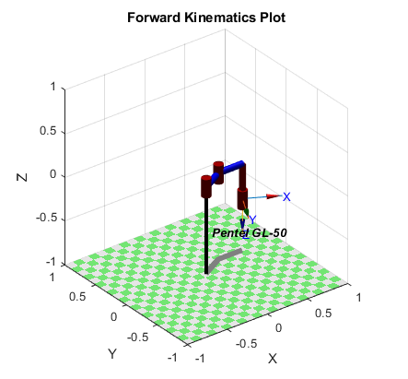

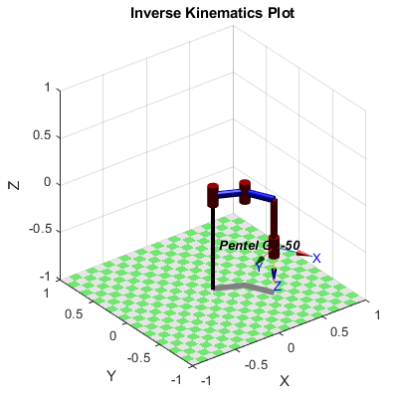

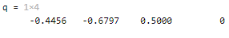

Here we can see the 4 joint angles the ikine function calculated to correspond to the homogeneous transformation matrix. In the second to last line of the code, the mask option is a 1x6 matrix that tells the ikine function which joints to ignore. Since this is a 4 degree of freedom robot, joint 5 and 6 have to be ignored.

**Problem 2:**

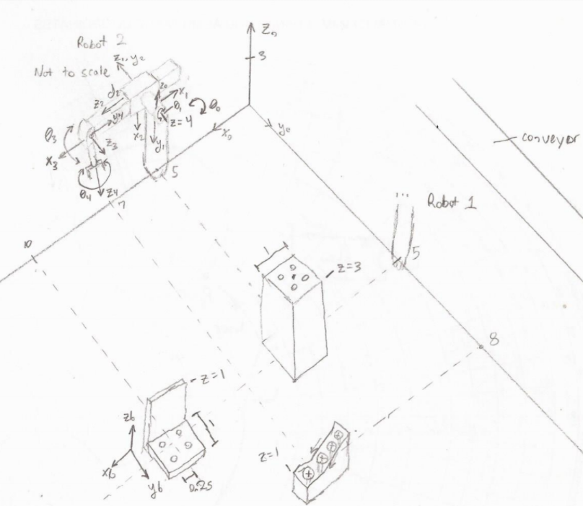

In the drawing, robot 1 is identical to robot 2. The task for robot 1 is to pick up parts off the conveyor and place them at specific points where robot 2 then uses them for assembly.

In the drawing of the robot, $z_{1}$ is chosen on the joint axis of the second joint which is revolute. $z_{2}$ is down the prismatic joint. $z_{3}$ is on the joint axis for joint 3 and $z_{4}$ is also on the joint axis; both are revolute.

**D-H parameters of Robot:**

(* variables):

|  |  |  |  |  |
| --- | --- | --- | --- | --- |
| # | $$θ$$ | d | a | $$α$$ |
| 0 | $$θ_{0}$$ | 0 | 0 | $$90°$$ |
| 0-1 | $θ_{1}$* | $$0$$ | 0 | $$0$$ |
| 1-2 | $$θ_{2}=90°$$ | $d_{2}$* | 0 | 0 |
| 2-3 | $θ_{3}$* | $$0$$ | 0 | $$90°$$ |
| 3-4 | $θ_{4}$* | $$d_{4}$$ | 0 | $$-90°$$ |

* In order to align $Z_{0}$ with $Z_{1}$ we rotate $90°$ CCW about the $X_{0}$ axis so $a_{0}=90°$.
* A rotation of $y_{1}$ CCW is needed to align $z_{1}$ with $z_{2}$ so $θ_{2}=90°$.
* In order to align $Z_{2}$ with $Z_{3}$ we rotate $90°$ CCW about the $X_{2}$ axis so $a_{3}=90°$.
* In order to align $Z_{3}$ with $Z_{4}$ we rotate $90°$ CW about the $X_{3}$ axis so $a_{4}=-90°$.
* $d_{4}$ is the distance to the tool.

General Formula for D-H matrices:

$$A_{n}\left[\begin{matrix}Cθ_{n} & -Sθ_{n}Ca_{n} & Sθ_{n}Sa_{n} & a_{n}Cθ_{n} \\ Sθ_{n} & Cθ_{n}Ca_{n} & -Cθ_{n}Sa_{n} & a_{n}Sθ_{n} \\ 0 & Sa_{n} & Ca_{n} & d_{n} \\ 0 & 0 & 0 & 1\end{matrix}\right]$$

Where $Cθ_{n}=cosθ_{n}$, $Sθ_{n}=sinθ_{n}$, etc.

Plug in ($C_{n}=cosθ_{n}, S_{n}=sinθ_{n}$):

$$A_{0}=\left[\begin{matrix}C_{0} & 0 & S_{0} & 0 \\ S_{0} & 0 & -C_{0} & 0 \\ 0 & 0 & 1 & 0 \\ 0 & 0 & 0 & 1\end{matrix}\right]$$

$$A_{1}=\left[\begin{matrix}C_{1} & -S_{1} & 0 & 0 \\ S_{1} & C_{1} & 0 & 0 \\ 0 & 0 & 1 & 0 \\ 0 & 0 & 0 & 1\end{matrix}\right]$$

$$A_{2}=\left[\begin{matrix}0 & -1 & 0 & 0 \\ 1 & 0 & 0 & 0 \\ 0 & 0 & 1 & d_{2} \\ 0 & 0 & 0 & 1\end{matrix}\right]$$

$$A_{3}=\left[\begin{matrix}C_{3} & 0 & S_{3} & 0 \\ S_{3} & 0 & {-C}_{3} & 0 \\ 0 & -1 & 0 & 0 \\ 0 & 0 & 0 & 1\end{matrix}\right]$$

$$A_{4}=\left[\begin{matrix}C_{4} & 0 & -S_{4} & 0 \\ S_{4} & 0 & C_{4} & 0 \\ 0 & -1 & 0 & d_{4} \\ 0 & 0 & 0 & 1\end{matrix}\right]$$

**Forward Kinematics:**

Multiply all of the matrices together starting from $A_{1}$ to $A_{4}$. The final T vector will contain the position of the end effector and the R matrix will contain the orientation of the end effector:

$$T={A_{0}A}_{1}A_{2}A_{3}A_{4}=\left[\begin{matrix}R & R & R & T \\ R & R & R & T \\ R & R & R & T \\ 0 & 0 & 0 & 1\end{matrix}\right]=\left[\begin{matrix}n_{x} & o_{x} & a_{x} & p_{x} \\ n_{y} & o_{y} & a_{y} & p_{y} \\ n_{z} & o_{z} & a_{z} & p_{z} \\ 0 & 0 & 0 & 1\end{matrix}\right]$$

$$A_{0}A_{1}=\left[\begin{matrix}C_{0}C_{1} & -C_{0}C_{1} & S_{0} & 0 \\ C_{1}S_{0} & -{C_{1}S}_{0} & {-C}_{0} & 0 \\ 0 & 0 & 1 & 0 \\ 0 & 0 & 0 & 1\end{matrix}\right]$$

$$A_{0}A_{1}A_{2}=\left[\begin{matrix}{-C}_{0}C_{1} & -C_{0}C_{1} & S_{0} & S_{0}d_{2} \\ -C_{1}S_{0} & -{C_{1}S}_{0} & {-C}_{0} & {-C}_{0}d_{2} \\ 0 & 0 & 1 & d_{2} \\ 0 & 0 & 0 & 1\end{matrix}\right]$$

$$A_{0}A_{1}A_{2}A_{3}=\left[\begin{matrix}{-C}_{0}C_{1}C_{3}{-C}_{0}C_{1}S_{3} & -S_{0} & C_{0}C_{1}C_{3}{-C}_{0}C_{1}S_{3} & S_{0}d_{2} \\ -C_{1}{C_{3}S}_{0}-C_{1}S_{0}S_{3} & C_{0} & C_{1}{C_{3}S}_{0}-C_{1}S_{0}S_{3} & {-C}_{0}d_{2} \\ 0 & -1 & 0 & d_{2} \\ 0 & 0 & 0 & 1\end{matrix}\right]$$

$$A_{0}A_{1}A_{2}A_{3}A_{4}=$$

Where

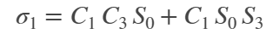



The transformation of parts coming down the conveyor are random, so a fixed camera is needed. The camera is used to identify the parts and its position with respect to the camera frame. $CAM$ represents the camera’s pose in world coordinates. $PC$ represents the parts pose with respect to the camera coordinate frame. $PA$ is the representation of the desired robot gripper pose at the location of the part.

$$P_{n}=CAM∙PC$$

Let $Z$ be the transformation of robot 1 base frame with respect to the world frame.

$$Z=\left[\begin{matrix}1 & 0 & 0 & 0 \\ 0 & 1 & 0 & 5 \\ 0 & 0 & 1 & 4 \\ 0 & 0 & 0 & 1\end{matrix}\right]$$

Now we must calculate for the robot pose $T_{n}$ for every part that it picks up. The inverse kinematics must be solved in real time:

$$T_{n}=Z^{-1}∙CAM∙PC∙{PA}^{-1}$$

Sequence of motions for robot 2:

* 1) Move to (10,4.5,2) (above bracket)
* 2) Move down to (10,4.5,0.5) (at bracket)
* 3) Grasp the bracket
* 4) Move up to (10,4.5,5)
* 5) Move to (5,4.5,5) (above post)
* 6) Move down to (5,4.5,3.5) (on top of post)
* 7) Release the bracket
* 8) Move to (5,4.5,5) (above post)
* 9) Move to (7,8,2) (on top of bolt)
* 10) Move down to (7,8,0.5) (at bolt)
* 11) Grasp the bolt
* 12) Move up to (7,8,6)
* 13) Move to (4.75,4.75,6) (At beam, above hole)
* 14) Move down to (4.75,4.75,3)
* 15) Release the bolt
* 16) Repeat steps 8-15

Most motions are fast motions as there is no need for a straight line motion between the two locations however, motion 6 and 14 must move in a straight line so that the bracket and the bolt align perfectly.

**Kinematic Equations:**

* Let $Z$ be the transformation of the robot base frame with respect to the world frame
$$Z=\left[\begin{matrix}1 & 0 & 0 & 5 \\ 0 & 1 & 0 & 0 \\ 0 & 0 & 1 & 4 \\ 0 & 0 & 0 & 1\end{matrix}\right]$$

* Let $T$ be the transformation of the end effector (tool) of the robot with respect to its base
* Let $P_{n}$ be the transformation of each step with respect to the world frame.
* Let ${PA}_{n}$ be the representation of the desired robot gripper pose with respect to the object coordinate frame.

$$Z∙T=P_{n}∙{PA}_{n}$$

$$Z∙T∙{PA}_{n}^{-1}=P_{n}$$

For step 1 we need the robot to move to (10,4.5,2) and rotate the gripper 90 degrees:

$${PA}_{1}=Trans\left(10,4.5,2\right)Rot\left(Z_{s},90\right)$$

$${PA}_{1}=\left[\begin{matrix}0 & -1 & 0 & 10 \\ 1 & 0 & 0 & 4.5 \\ 0 & 0 & 1 & 2 \\ 0 & 0 & 0 & 1\end{matrix}\right]$$

$${PA}_{1}^{-1}=\left[\begin{matrix}0 & 1 & 0 & -4.5 \\ -1 & 0 & 0 & 10 \\ 0 & 0 & 1 & -2 \\ 0 & 0 & 0 & 1\end{matrix}\right]$$

Now the transformation for the first step can be found:

$$Z∙T∙{PA}_{1}^{-1}=P_{1}$$

$$\left[\begin{matrix}1 & 0 & 0 & 5 \\ 0 & 1 & 0 & 0 \\ 0 & 0 & 1 & 4 \\ 0 & 0 & 0 & 1\end{matrix}\right]\left[\begin{matrix}n_{x} & o_{x} & a_{x} & p_{x} \\ n_{y} & o_{y} & a_{y} & p_{y} \\ n_{z} & o_{z} & a_{z} & p_{z} \\ 0 & 0 & 0 & 1\end{matrix}\right]\left[\begin{matrix}0 & 1 & 0 & -4.5 \\ -1 & 0 & 0 & 10 \\ 0 & 0 & 1 & -2 \\ 0 & 0 & 0 & 1\end{matrix}\right]=P_{1}$$

$$P_{1}=\left[\begin{matrix}-o_{x} & n_{x} & a_{x} & 10o_{x}-\frac{9}{2}n_{x}-2a_{x}+p_{x}+5 \\ {-o}_{y} & n_{y} & a_{y} & 10o_{y}-\frac{9}{2}n_{y}-2a_{y}+p_{y} \\ -o_{z} & n_{z} & a_{z} & 10o_{z}-\frac{9}{2}{n_{z}-2a_{z}+p}_{z}+4 \\ 0 & 0 & 0 & 1\end{matrix}\right]$$

For step 2 and 3, we need the robot to move down to (10,4.5,0.5) and grasp the bracket. The kinematic equation would be the following for this action:

$$Z∙T∙{PA}_{2,3}^{-1}∙G=P_{2,3}$$

Where

$${PA}_{2,3}^{-1}={(trans\left(0,0,-1.5\right))}^{-1}=\left[\begin{matrix}1 & 0 & 0 & 0 \\ 0 & 1 & 0 & 0 \\ 0 & 0 & 1 & 1.5 \\ 0 & 0 & 0 & 1\end{matrix}\right]$$

And $G$ is the transformation to grasp the object.

Step 4 and 5 can be done simultaneously where the robot brings the bracket over the post to (5,4.5,5).

$${PA}_{4,5}=Trans\left(5,4.5,5\right)$$

$${PA}_{4,5}=\left[\begin{matrix}1 & 0 & 0 & 5 \\ 0 & 1 & 0 & 4.5 \\ 0 & 0 & 1 & 5 \\ 0 & 0 & 0 & 1\end{matrix}\right]$$

$${PA}_{4,5}^{-1}=\left[\begin{matrix}1 & 0 & 0 & -5 \\ 0 & 1 & 0 & -4.5 \\ 0 & 0 & 1 & -5 \\ 0 & 0 & 0 & 1\end{matrix}\right]$$

Now the transformation for the first step can be found:

$$Z∙T∙{PA}_{4,5}^{-1}=P_{4,5}$$

$$\left[\begin{matrix}1 & 0 & 0 & 5 \\ 0 & 1 & 0 & 0 \\ 0 & 0 & 1 & 4 \\ 0 & 0 & 0 & 1\end{matrix}\right]\left[\begin{matrix}n_{x} & o_{x} & a_{x} & p_{x} \\ n_{y} & o_{y} & a_{y} & p_{y} \\ n_{z} & o_{z} & a_{z} & p_{z} \\ 0 & 0 & 0 & 1\end{matrix}\right]\left[\begin{matrix}1 & 0 & 0 & -5 \\ 0 & 1 & 0 & -4.5 \\ 0 & 0 & 1 & -5 \\ 0 & 0 & 0 & 1\end{matrix}\right]=P_{4,5}$$

$$P_{4,5}=\left[\begin{matrix}n_{x} & o_{x} & a_{x} & p_{x}-5n_{x}-\frac{9}{2}o_{x}-5a_{x}+5 \\ n_{y} & o_{y} & a_{y} & p_{y}-5n_{y}-\frac{9}{2}o_{y}-5a_{y} \\ n_{z} & o_{z} & a_{z} & p_{z}-5n_{z}-\frac{9}{2}o_{z}-5a_{z}+4 \\ 0 & 0 & 0 & 1\end{matrix}\right]$$

The transformations for the rest of the actions are performed the same way.

**MATLAB:**

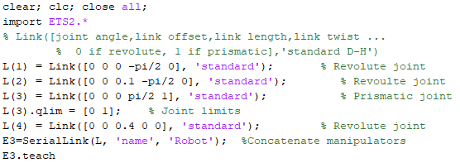



**Problem 4:**

The velocity for joint 1 and 2:

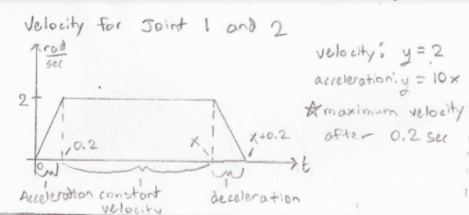

The task requires joint 1 to rotate $0.25 rad=∆q$. First we need to check if we can assign a triangular velocity profile or a trapezoidal velocity profile using the following:

$$\sqrt{a_{max}∙∆q}≤v_{max}$$

$$\sqrt{10*0.25}≤2$$

$1.581≤2$, we can use a triangular velocity profile

For a triangular profile we can find the total time, $T$, for the joint to complete the rotation by using the equation:

$$T=2\sqrt{\frac{∆q}{a_{max}}}=2\sqrt{\frac{0.25}{10}}$$

$$T=0.31623 sec$$

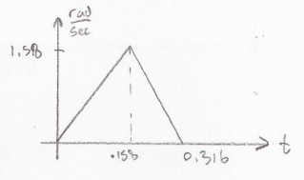

The task requires joint 2 to rotate $-0.4 rad$. $∆q=0.4 rad$. Check if we can assign a triangular velocity profile or a trapezoidal velocity profile:

$$\sqrt{a_{max}∙∆q}≤v_{max}$$

$$\sqrt{10∙0.4}≤2$$

$2≤2$, we can use a triangular velocity profile

Total time $T$ for the joint to complete the rotation:

$$T=2\sqrt{\frac{∆q}{a_{max}}}=2\sqrt{\frac{0.4}{10}}$$

$$T=0.4 sec$$

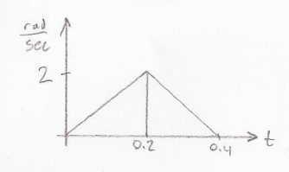

The velocity for joint 3:

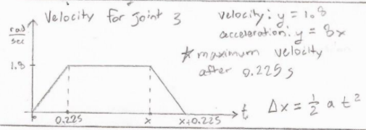

The task requires joint 3 to rotate $0.75 rad=∆q$. Check if we can assign a triangular velocity profile or a trapezoidal velocity profile:

$$\sqrt{a_{max}∙∆q}≤v_{max}$$

$$\sqrt{8∙0.75}≤1.8$$

$2.45≰1.8$, we must use a trapezoidal velocity profile

For a trapezoidal velocity profile we can find the total time, , for the joint to complete the rotation by using the equation:

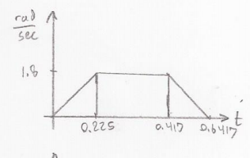

We can double check that the velocity profile is correct by breaking the trapezoid into three sections and using the formula:

$$∆q=v_{max}t+\frac{1}{2}at^{2}$$

$${∆q}_{1}=0∙0.225+\frac{1}{2}∙8∙{0.225}^{2}=0.2025rad$$

$${∆q}_{2}=1.8∙0.192+\frac{1}{2}∙0∙{0.192}^{2}=0.345 rad$$

$${∆q}_{3}=0∙0.225+\frac{1}{2}∙8∙{0.225}^{2}=0.2025 rad$$

$$2.5=∆q={∆q}_{1}+{∆q}_{2}+{∆q}_{3}=0.2025+0.345+0.2025$$

$0.75=0.75$, passes check

The velocity for joint 4:

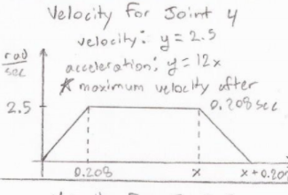

The task requires joint 4 to rotate $0.1 rad=∆q$. Check if we can assign a triangular velocity profile or a trapezoidal velocity profile:

$$\sqrt{a_{max}∙∆q}≤v_{max}$$

$$\sqrt{12∙0.1}≤2.5$$

$1.095≤2.5$, we can use a triangular velocity profile

Total time $T$ for the joint to complete the rotation:

$$T=2\sqrt{\frac{∆q}{a_{max}}}=2\sqrt{\frac{0.1}{12}}$$

$$T=0.1826 sec$$

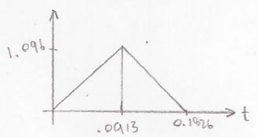

The velocity for joint 5:

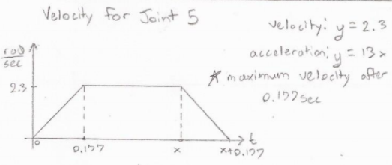

The task requires joint 5 to rotate $-0.1 rad$. $0.1 rad=∆q$. Check if we can assign a triangular velocity profile or a trapezoidal velocity profile:

$$\sqrt{a_{max}∙∆q}≤v_{max}$$

$$\sqrt{13∙0.1}≤2.3$$

$1.14≤2.3$, we can use a triangular velocity profile

Total time $T$ for the joint to complete the rotation:

$$T=2\sqrt{\frac{∆q}{a_{max}}}=2\sqrt{\frac{0.1}{13}}$$

$$T=0.1754 sec$$

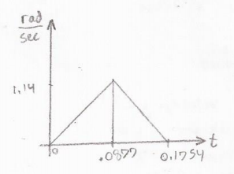

The velocity for joint 6:

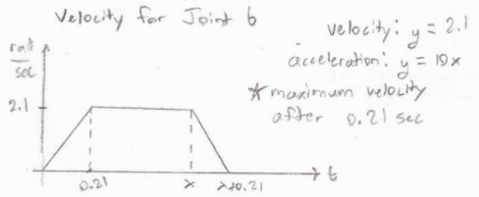

The task requires joint 6 to rotate $0.5 rad=∆q$. Check if we can assign a triangular velocity profile or a trapezoidal velocity profile:

$$\sqrt{a_{max}∙∆q}≤v_{max}$$

$$\sqrt{10∙0.5}≤2.1$$

$2.236≰2.1$, we must use a trapezoidal velocity profile

For a trapezoidal velocity profile we can find the total time, , for the joint to complete the rotation by using the equation:

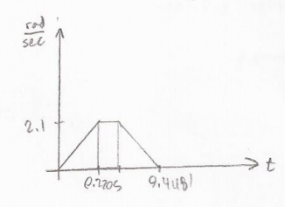

We can double check that the velocity profile is correct by breaking the trapezoid into three sections and using the formula:

$$∆q=v_{max}t+\frac{1}{2}at^{2}$$

$${∆q}_{1}=0∙0.21+\frac{1}{2}∙10∙{0.21}^{2}=0.2205 rad$$

$${∆q}_{2}=2.1∙0.0281+\frac{1}{2}∙0∙{0.0281}^{2}=0.05901 rad$$

$${∆q}_{3}=0∙0.21+\frac{1}{2}∙10∙{0.21}^{2}=0.2205 rad$$

$$2.5=∆q={∆q}_{1}+{∆q}_{2}+{∆q}_{3}=0.2205+0.05901+0.2205$$

$0.5=0.5$, passes check

Joints 1,2,4 and 5 have a triangular velocity profile while joints 3 and 6 need a trapezoidal velocity profile.

**MATLAB:**

In the MATLAB code I imported the Puma 560 robot because it is a 6 degree of freedom robot where we can test out the velocity profiles above.

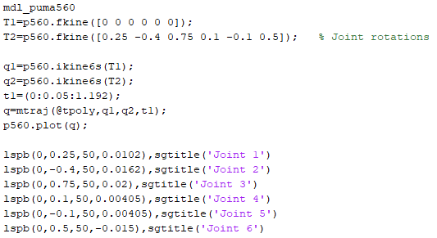



This is an animation of the Puma robot completing all 6 joint rotations.

**Position, Velocity, and Acceleration Profiles:**

